**Interactive water management map of Wellington**

**Cartography Lab**

**ETHZ, FS 16**

**Professor:**

Prof Dr Lorenz Hurni

**Supervisors:**

Dr Christian Häberling

Dr Hans-Rudolf Bär

**Students:**

Giulio Tagliaferro [giuliot@ethz.ch](mailto:giuliot@ethz.ch)

Matteo Lehmann [mlehmann@ethz.ch](mailto:mlehmann@ethz.ch)

Zurich, 30 June 2016

**Table of content**

1. Introduction 4

2. Objectives of the Cartography Lab 5

3. Basic data 6

4. Technical equipment 6

5. Project steps and implementation 7

5.1 Data Visualization 7

5.2 Basemap choice 10

5.3 GUI design 10

5.4 Interactive Features 12

6. Results 15

7. References 16

**List of Figures**

**Figure 1:** Sewage system of London, 1882 (Ancestry, 2016) 4

**Figure 2:** Drainage system of London, 1950s (H&H Geological Society, 2016) 5

**Figure 3:** Overview visualisation mode 9

**Figure 4**: Categorized visualization mode 9

**Figure 5:** Redirection button in landing page 10

**Figure 6:** Page's Logo 10

**Figure 7:** Menu-bar with two layers 11

**Figure 8:** Example of buttons with zoom higher or equal to 14 11

**Figure 9:** Map Description popup window 12

**Figure 10:** Geocoder example 12

**Figure 11:** Pipe inspector 13

**Figure 12:** Legend for the waste water network 13

**Figure 13**: Timeslider 14

**Figure 14**: Flow direction 14

**Figure 15**: Elevation query 14

**List of Tables**

**Table 1**: Semantic classification of the materials 8

**Table 2**:Categories for the used diameter 9

# Introduction

Water-supply and water collection is a vital part of the infrastructure of a city. Although this system could be hidden and not visible, it is still essential to maintain clean and tidy every city around the world.

Could be interesting to point out that in most of the countries the ensemble of the water networks (supply, drainage and treatment) is the most valuable asset of a city.

In Figure 1 and Figure 2 there are shown examples of respectively the water treatment and the drainage system maps of London. The topic has not been treated extensively in cartography. This kind of networks are usually represented only in cadastral maps together with gas and electrical networks.

The choice of Wellington as location for the thematic map is basically based on two main reasons: this kind of data are generally not provided free of charge (e.g. cadaster of Zurich). The city of Wellington makes these kind of data freely available. Furthermore, the city of Wellington has an astonishing number of free available data included numerous layers covering almost every topic.

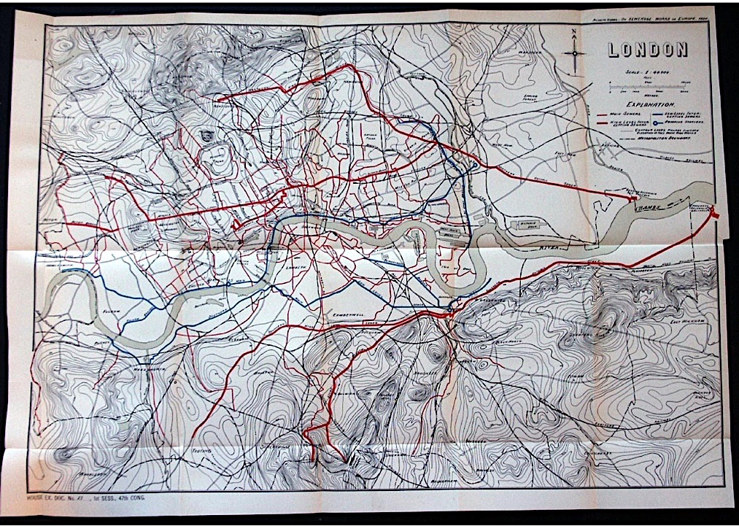

**Figure 1:** Sewage system of London, 1882 (Ancestry, 2016)

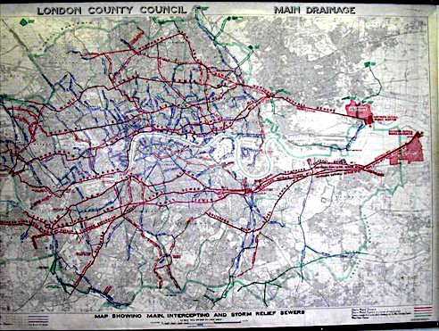

**Figure 2:** Drainage system of London, 1950s (H&H Geological Society, 2016)

# Objectives of the Cartography Lab

The main idea behind of this Cartography Lab is to create an interactive map based on the water management in Wellington, New Zealand.

The initial idea behind this cartography Lab was to develop an interactive map for specialized workers, that requires prior knowledge about sewage systems. This means that, unfortunately, it is more suited for technicians than for general public. This project could be easily adapted to other cities of similar dimension (if the data are available). The map will be Web-based and accessible to a broad public and it will provide a faster and easier way to graphically visualize the network and its properties. The final product will be published on the Web and it could potentially be linked to the City Council Web Site[1].

It is important to notice that the final product of this Cartography Lab is only a prototype. This means that we developed a lot of possible interaction between user and application but the content is extended only on storm water and waste water management.

# Basic data

The data have been downloaded from a NZ geoportal (<https://koordinates.com/>) from which the Shapefiles of the waste and storm water networks can be freely downloaded.

Among the numerous data available for the city of Wellington, the following dataset have been used:

* Waste water network, containing the geometry of the pipes and information about hydraulic diameter, materials, slope, and year of construction (or maintenance), id of the upstream node, and of the downstream node.
* Storm water network, containing the geometry of the pipes and information about hydraulic diameter, materials, slope, and year of construction (or maintenance).
* Node of the waste water network, containing the position of the nodes.
* A DTM at 5 meters resolution and 0.3 m accuracy, covering the city council of Wellington.

All the data are published using two licenses: the *CC BY-SA 3.0 (Attribution-ShareAlike 3.0 Unported)[2]* for basemap data such as DTM and municipality boundaries and the *CC BY-NC 3.0 NZ (Attribution-NonCommercial 3.0 New Zealand)[3]* for the data of the networks.

The data of the basemap are the OpenStreet map data styled and used through the mapbox interface.

# Technical equipment

The Map has been developed using the three key technologies for web development: html , JavaScript and CSS. Furthermore, a list of JavaScript libraries have been used:

* W2ui used to realize the GUI[4]
* JQuery. needed mostly for W2UI.js[5]
* Mapbox GL core library used for the visualisation of the cartographic data[6]
* Mapbox cartographic library based on Leaflet.js (mostly used for the geocoder[7])
* Papa Parse to parse easily and efficiently csv text files.[8]
* NoUIslider for the creation of the time slider[9]

It is worth mentioning that Mapbox GL uses vector tiles for the visualisation of the geodata. This allows the usage of relatively large geojson data (10-20 Mb) with reasonable loading speed.

* GDAL (Geospatial Data Abstraction Library) and python cgi script were used for the query the DTM for the elevation.
* Mapbox studio was used for the design of the basemap.
* Adobe illustrator and Inkscape were used for the manipulation of vector graphics.
* The GIS software QGIS was used to pre-process and convert data to suitable format for the web.
* Fortran code compiled with gfortran[10] has been used for the manipulation of text file.
* During the whole development of the code the control version software Git[11] was used a repository was created on Git-Hub[12].

# Project steps and implementation

## Data Visualization

Two visualization mode of the network are implemented in the map.

An overview of the whole network (see Figure 3) is visible at a higher zoom level (less than 14). There, no semantic information is displayed and the geometrical content is displayed through tiny line that allow the user to clearly see the basemap for the orientation.

The second visualization mode appears at a zoom level lower than 14, where the pipes of the networks are categorized using two properties and two characteristics: line widths for diameter and colors for the material.

Due to the presence of numerous different materials, a semantic generalization was needed. In Table 1 the semantic classes and the different materials belonging to each class are presented.

The conversion between hydraulic diameter and line width was done using the two following formulas:

* for the waste water network
* fot the storm water network

In the two formula the diameter (D) is given in mm and the resulting line width (LW) is in pixels.

The two formulas were found by starting from the consideration that a linear scale is not probably suitable for the case due to the big difference in the diameters (from 120 mm to more than 6000mm).

Since Mapbox GL does not allow styles based on continuous formula the diameters had to be categorized.

|  |  |
| --- | --- |
| Class | Materials |
| Ceramics | Brick  Earthenware  Eare  Stoneware |
| Metals | Steel - spiral weld  Steel - epoxy lined  Steel - cement lined  Steel  Galvanised Steel  Galvanised Iron  Ductile Iron - cement lined  Ductile Iron  Copper  Cast Iron |
| Concrete | Reinforced Concrete  Concrete |
| Fiber composite | Pitch Fiber  Asbestos Cement |
| PVC plastics | uPVC  PVC - Blue Brute  Polyvinyl Chloride  mPVC |
| Polyethylene plastics | Polyethylene  Medium Density Polyethylene  High Pressure Polyethylene  High Density Polyethylene |
| Other , unknown | PLST  NPRN  NULL |

**Table 1**: Semantic classification of the materials

|  |  |
| --- | --- |
| Waste water network | Storm water network |
| 0 – 160 mm | 0 - 355 mm |
| 161 – 200 mm | 356 - 760 mm |
| 201 – 400 mm | 761 - 1530 mm |
| 401 – 800 mm | 1531 - 3500 mm |
| 801 - 2000 mm | 3501 - 6000 mm |

**Table 2**:Categories for the used diameter

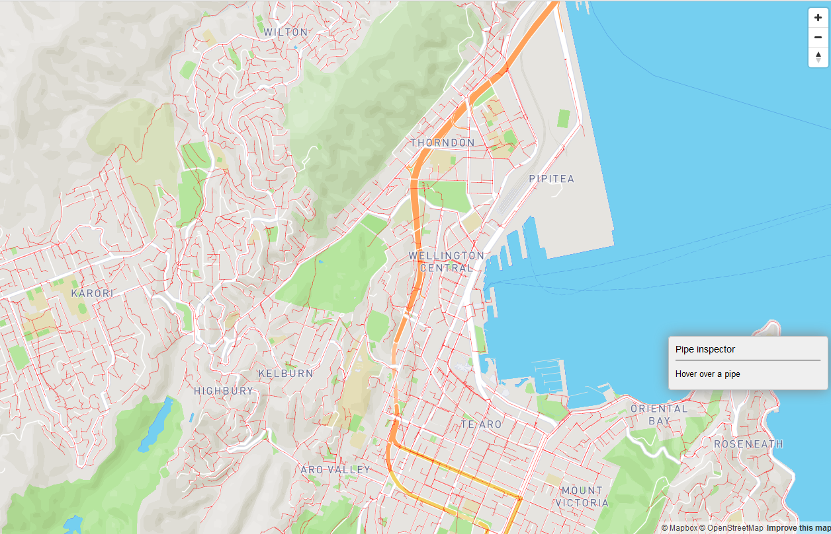

**Figure 3:** Overview visualisation mode

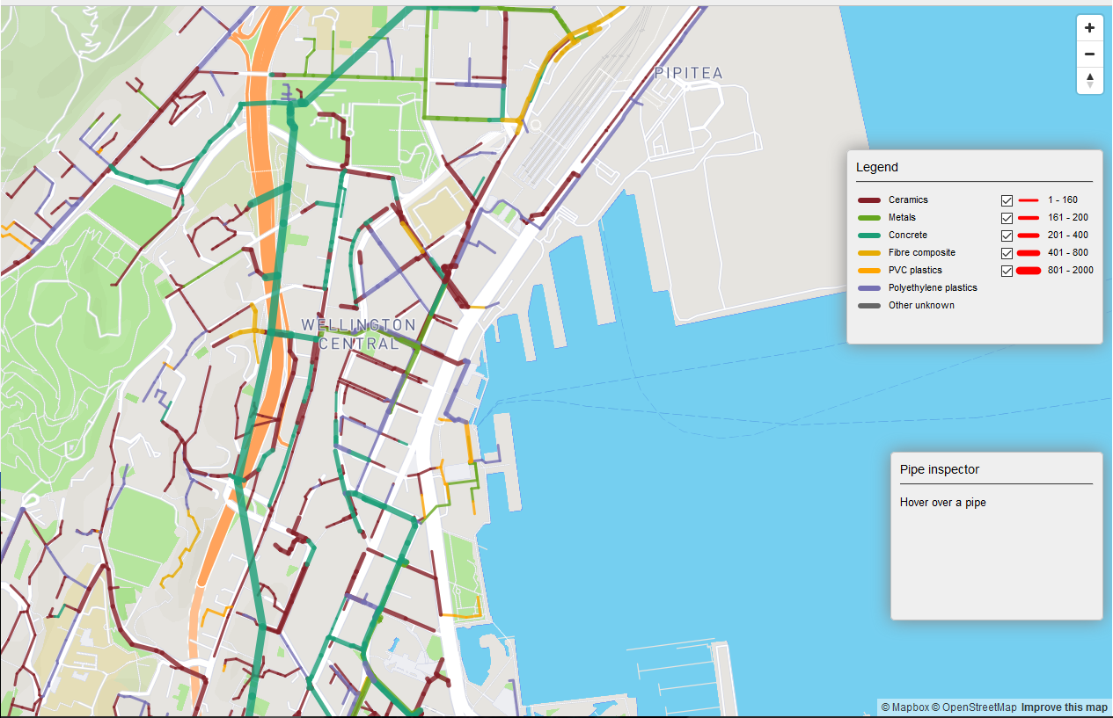

**Figure 4**: Categorized visualization mode

## Basemap choice

For the design of the basemap we consider to include useful information related to the water network, such as:

* Street and street name (the water network is closely tight to the road).
* Buildings
* Hillshading (gives an overall impression of the topography)
* Contour lines for a better and quantitative understanding of the topography, showed only to closer zooms.
* Water bodies.
* A general land cover classification map.
* Label for the different neighbourhood of Wellington.

## 5.3 GUI design

The landing page is principally a decorative element and it is used to welcome the users to the map. The only interactive feature is, indeed, the button that redirect the user directly to the interactive map.



**Figure 5:** Redirection button in landing page

In the GUI of the Water Management Map of Wellington, there are principally the following elements:

**Page’s Logo**

The logo is a clickable self-drawn icon, which gives the possibility to the user to refresh the page.

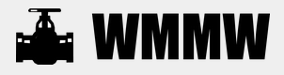

**Figure 6:** Page's Logo

**Menu Button**

The Menu button opens a small sidebar (centred under the button), in which there is the possibility to show or hide the two layers. The Menu has the same functionality of a simple Radio Button.

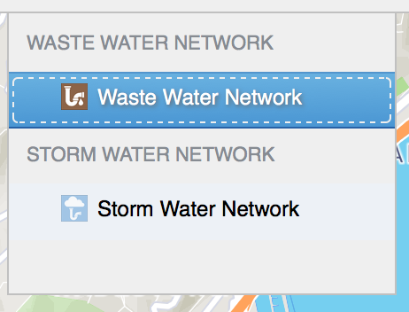

**Figure 7:** Menu-bar with two layers

**Time Slider and Legend buttons**

These two buttons are two hide and check options. After the toggling, they show or hide two different elements of the web-page, like the time slider and the legend. By default, these two elements compare automatically with respect to the actual zoom: if the zoom is less than 14, the time slider is usable while with a zoom smaller than 14 the time slider button is deactivated and it is only possible to interact with the layer and its button.

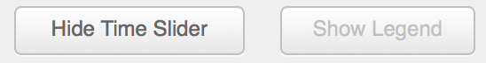

**Figure 8:** Example of buttons with zoom higher or equal to 14

**Map Description and Impressum**

The Map Description and Impressum buttons open two further html files in overlay containing information regarding respectively the functionalities of the interactive map and the metadata.

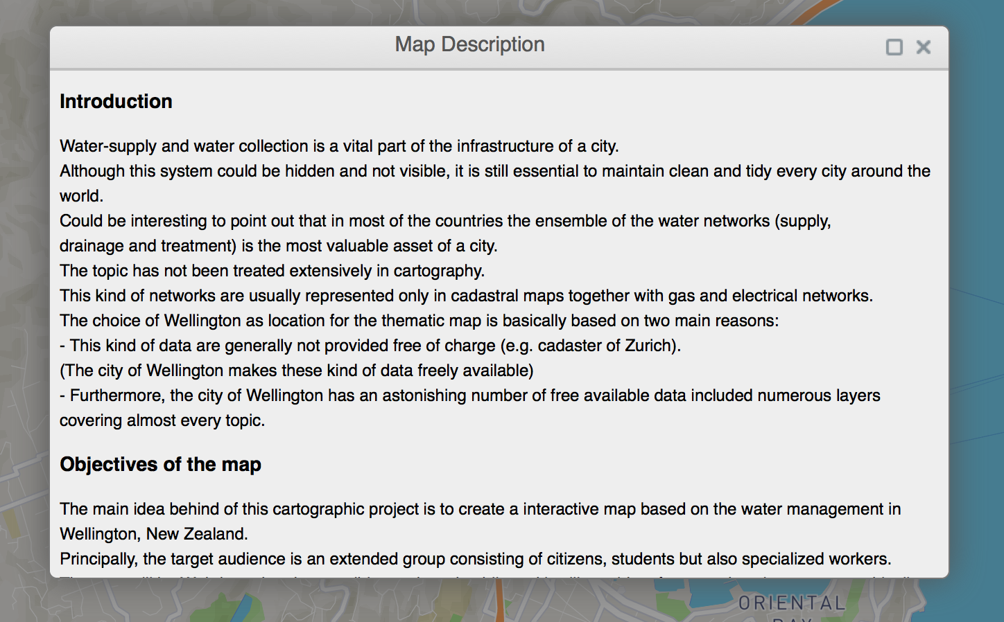

**Figure 9:** Map Description popup window

## 5.4 Interactive Features

Different Interactive features are imbedded in the map:

### **Geocoder**

The geocoder integrated in the GUI allows the user to search for name of location inside the Wellington area. The resulting address are queried looking in the proximity of Wellington city center or excluded if they lay completely out of the bounding box of the city.

Once the result is clicked, the map is zoomed and panned to the location. An example of the results of a search location is shown in Figure 10.

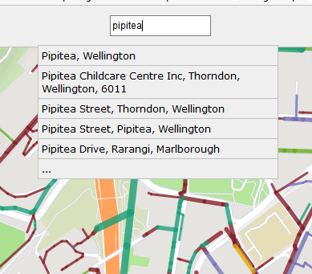

**Figure 10:** Geocoder example

### **Pipe Inspector**

The pipe inspector is a feature that allows the user to explore in details the properties of a pipe. When the user hovers the mouse over a certain pipe, a sketch with a section of the pipe and some important parameter (such as installation date, material, gradient, diameter (when the pipe is circular) or hydraulic diameter) appears.

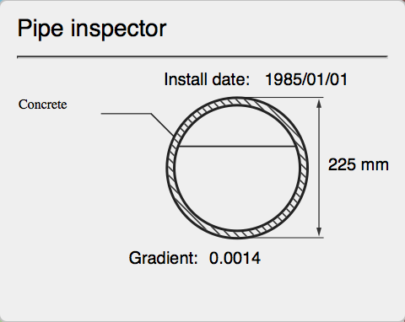

**Figure 11:** Pipe inspector

### **Legend**

The legend (see Figure 12) changes dynamically by switching between the networks. It can be visualized only if the network is not in the overview mode.

It allows checking or unchecking the visualization of pipes of different diameters.

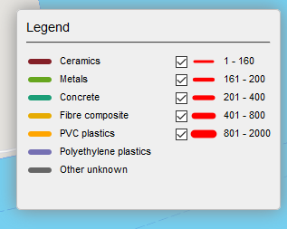

**Figure 12:** Legend for the waste water network

### **Time slider**

This feature is present only in the overview mode and allows the user to select which timespan has to be visualized on the map. In this way a technician can visualize which part of the network was installed or changed recently. The time slider is shown in Figure 13.

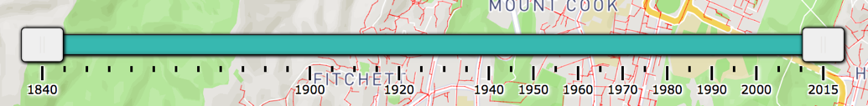

**Figure 13**: Timeslider

### **Flow Direction**

This feature allows the user to see in which direction the water flows inside the pipes, the flow direction are shown using small arrows on top of the pipes. This features is enabled only after the zoom level 17 to prevent the map from arrow crowding. An example can be seen in Figure 14.

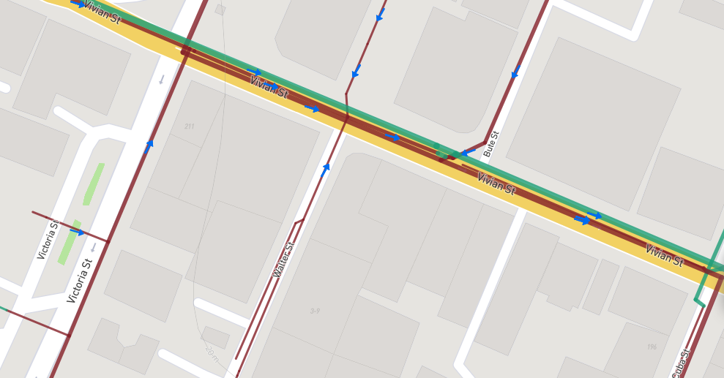

**Figure 14**: Flow direction

### **Height query**

The user has the possibility to query for the elevation in Wellington by left-clicking with the mouse in a point on the map. The value displayed (rounded at decimeter level) is the corresponding pixel in the 5m resolution DTM of Wellington.

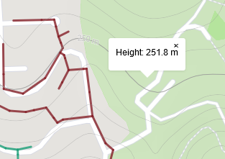

**Figure 15**: Elevation query

# Results

Even if the final result is still a prototype, we can proudly present it as a success. This because it accomplishes all the requirements that we set at the beginning of the semester.

Of course there are some parts or elements that have to be improved or still implemented but the goal of the project was to give the possibility to workers or other interested persons to retrieve graphical and technical data easily on the web.

**Propositions of improvements**

There is the possibility to improve few aspects of the GUI and also of the map content:

* Improve the interactivity of the GUI, for example by implementing a Menu-bar with check-boxes or by creating a more detailed landing page. It could be also interesting to add new links between the map and the social networks (Facebook, Twitter, etc.) and also to implement a “Print button”.
* The content of the map could also be improved by adding new layers and new information (e.g. the position of the water purification centres, or the position of the manholes).
* The velocity of displaying the layers should also be improved.

**Learning experiences**

This project allowed us to learn how to create and develop a cartographic project without any initial suggestions or hints coming from the assistants (they helped us during the implementation parts). This was an interesting opportunity to understand and apply what we learned during the different cartography courses in the Bachelor or Master study.

Furthermore, we learned how to deal with the implementation problems as well as the organisational problems (it is not every time easy to organize the work between the member of a group). Of course it is also still a challenge to deal with time and others restrictions due e.g. to the lack of data or experience.

# References

* Ancestry, 2016:

<http://freepages.genealogy.rootsweb.ancestry.com/~genmaps/genfiles/COU_files/ENG/LON/hering_lon-sewer_1882.html>

H&H Geological Society, 2016:

<http://www.hhgs.org.uk/monthly_meetings/previous_meetings/thames_tideway/thames_tideway.html>

1. **City Council Web Site**: http://wellington.govt.nz
2. # Source: http://creativecommons.org/licenses/by-sa/3.0/

  
3. # Source: http://creativecommons.org/licenses/by-nc/3.0/nz/

  
4. **Source:** http://w2ui.com/web/
5. **Source:** http://w2ui.com/web/
6. **Source:** https://www.mapbox.com/mapbox-gl-js/api/
7. **Source:** https://www.mapbox.com/mapbox.js/api/v2.4.0/
8. **Source:** http://papaparse.com/
9. **Source:** http://refreshless.com/nouislider/
10. **Source:** https://gcc.gnu.org/wiki/GFortran
11. **Source:** https://git-scm.com/
12. **Source:** https://github.com/team1skyblueteo/Carto-Lab-Terroni